**RE-OPENING A PERIOD IN GENERAL LEDGER**

1. Go to the Company file (G-F-1).
2. Find the period to open. Cannot re-open a period if there are any periods closed after that period. Must re-open periods in order backwards.
3. Highlight the period to open and then click the update button.
4. The system password box will pop-up. Enter the password. Change the closed flag to open and save. The period status will then change to open once the process is finished.

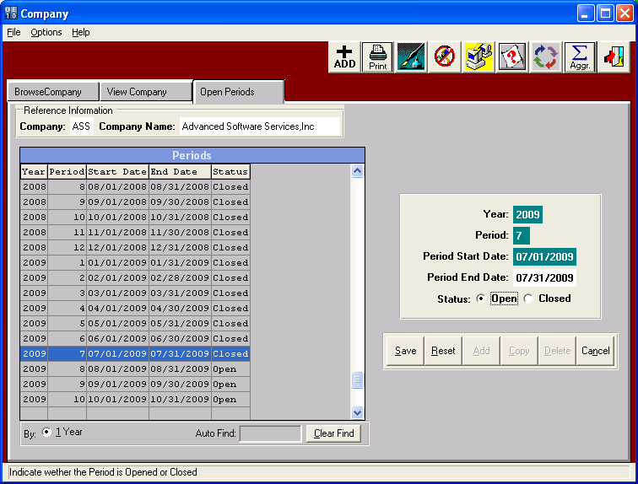

**Closing a period in General Ledger**

1. Go to the close month menu option on the general ledger menu. (G-C)
2. Enter the ending date of the period to close. Click ok and wait for the report to print and the process to complete. A message will appear to let you know the first open period has changed to the next period.